shared leadership in action webinar: presenter biographies
Heather Carter
Heather Carter is the Director of Services for the Center for a Non Violent Community. Her commitment to this field began in 1997 as a Volunteer Advocate in our Emergency Shelter. She has held positions as Legal Advocate, Domestic Violence and Sexual Assault counselor, Emergency and Transitional Shelter Coordinator and now Co-Director.

Deanna Roller
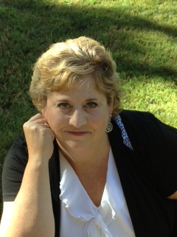
Deanna Roller is the Fiscal Director for a Center for a Non Violent Community. She has 20 plus years in bookkeeping and accounting and has worked with various companies and owned her own business for ten of those years. Deanna was drawn to the agency in 2010 when she applied for a part-time bookkeeping position and now serves as co-director for the agency. In her professional life, she has learned many of her job skills on the ground floor; facing many challenges along the way; making good and bad choices and lots of mistakes, and also experiencing success. Deanna grew up surrounded by domestic violence from the time she was born into her late teens and fells that she is in a place of healing and support that enables her to progress in her own personal growth. Her biggest accomplishment is that she have been married to a wonderful husband for almost 20 years and have two teenage children that are beautiful in every way.
Blue Shield of California Foundation is an Independent Licensee of the Blue Shield Association

Laura Sunday
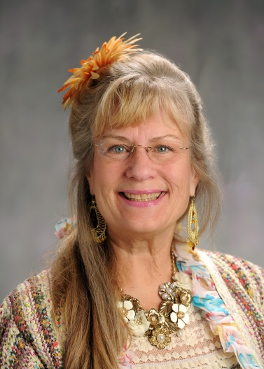
Laura Sunday has a passion for life and building safer communities. She has 30 years of experience in designing and delivering training. Sunday has tutored special needs children and facilitated the Children’s Program at the Center for a Non Violent Community’s (CNVC) emergency shelter for children who have been exposed to violence and trauma. She currently is the Community Services Director at CNVC and coordinates Tuolumne County’s domestic violence, sexual assault and bullying prevention programs, working with pre-school aged children to adults to uncover the roots of violence and shift social norms. Her focus is on creating inclusive violence-free schools and communities by fostering authentic youth engagement and leadership development in the prevention of teen dating violence, by providing media tools, support and training to youth, educators and youth service providers. Laura Sunday’s goal is to provide community members with tools to interact in peaceful ways, resolving conflicts and investing in the next generation of leaders. Ms. Sunday is passionate about People discovering their strengths and following their dreams. She is an active member of Leadership Tuolumne County and the YES Partnership. For fun, she seeks ways to be creative by playing the piano, scrapbooking and going on adventures with her husband Scott and golden retriever, Kira.

Stacy Umezu
Stacy Umezu is the Programs Co-Director at Community United Against Violence in San Francisco, CA. As one-half of the Programs Co-Directorship, he is responsible for overseeing the creation and implementation of CUAV's programmatic strategies, focusing particularly on local organizing and membership building efforts. He also serves on CUAV's internal Support and Accountability Team which works to ensure that all staff members feel fully supported and stay accountable to the daily work of the organization. Stacy has been a part of the CUAV collective since shortly before the transition to a shared leadership structure and has served on the team implementing the new structure since its inception. Stacy came to CUAV in 2008 with a strong background in organizing LGBTQ students on college campuses across the country, on issues ranging from affordability issues to campus climate.

