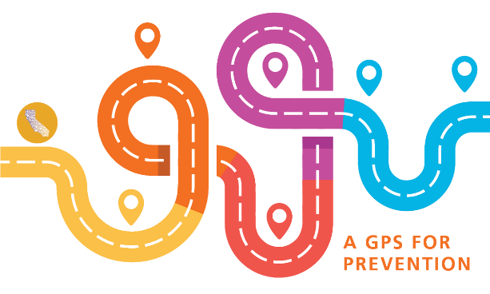

Creating & Using Logic Models for Program Planning and Evaluation
Thursday, December 19th - 10:30 am to 12:00 pm

- What is the change we want to see happen?

- What are the prevention activities/programs that will be implemented to meet this goal?

- What specific changes do we expect to see immediately after we implement this activity? (knowledge, attitude, behavior, beliefs)

- What changes do we expect to see within one year after we implement this activity?

- What will be the long-term effects of this activity? (On the individual? On the community? etc…)

- What are your assumptions about how this program will work?

- What are the external factors within which this effort will operate?

